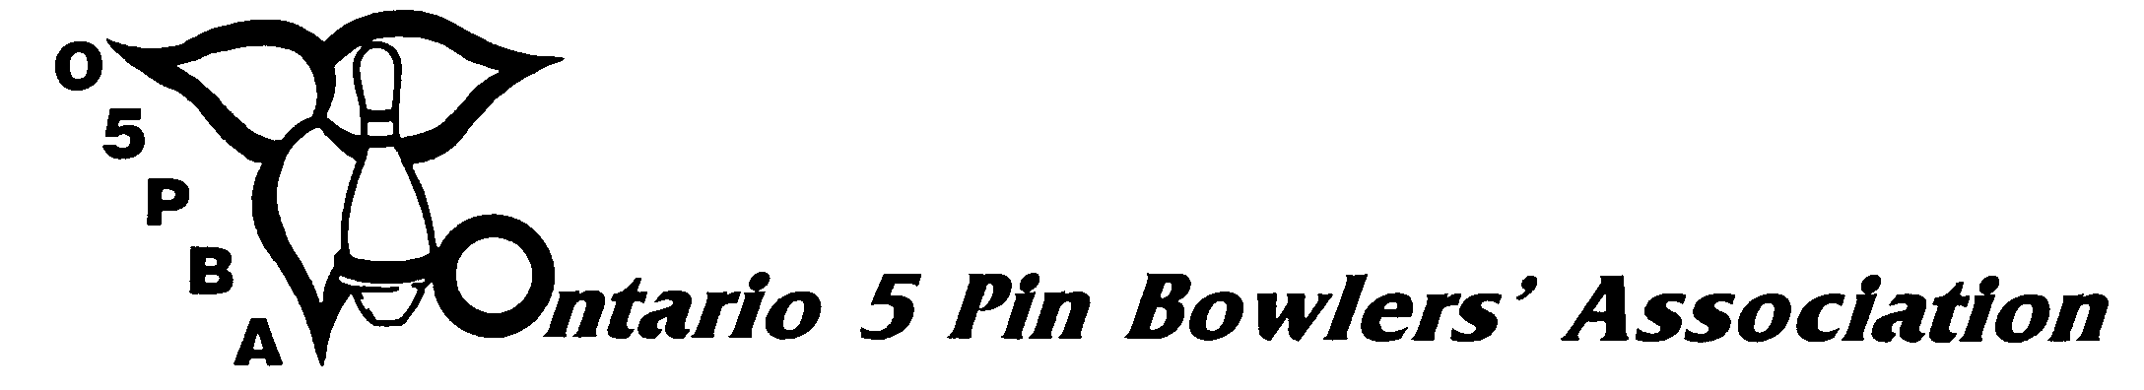
3 Concorde Gate, Suite 302, Toronto, Ontario, M3C 3N7
Telephone: (416) 426-7167 Fax: (416) 426-7364 E-Mail: o5pba@o5pba.ca Website: www.o5pba.ca

2014-2015 O5PBA YEAR-END AWARDS
- ORDER FORM -

ZONE/DC ASSOCIATION:
ORDERED BY:

DATE ORDERED:

SHIP ORDER TO:

Quantity Description Price Total

________ Merit Bar w/Executive Pin $5.00 $

________ League Champion Pin $1.50 $

TOTAL AMOUNT OF ORDER: $

SHIPPING CHARGES: $
(Under 50 Pins) - $5.00
(50+ Pins) – No Charge

SUB-TOTAL: $

13% HST: $

GRAND TOTAL: $

Please enclose a cheque made payable to the "ONTARIO 5 PIN BOWLERS’ ASSOCIATION”
with your order.

